Contents

Cloud 1

Software as a Service 1

Platform as a Service 1

Backend as a Service 2

Infrastructure as a Service 2

Differences between IaaS, IaaS, PaaS 2

Why Cloud Computing is better compared to other Technologies for this situation 3

solution 4

Conclusion 4

Bibliography 4

# Cloud

cloud computing is a computer system in which data and software are stored mainly on a central computer, to which users have access over the Internet” (cloud-computing noun - Definition, pictures, pronunciation and usage notes | Oxford Advanced American Dictionary at OxfordLearnersDictionaries.com, 2020).

* Cloud computing can be Categorizing according to the service architecture and the accessibility

Cloud has 3 main service architectures.

1. SaaS (Software as a Service)
2. PaaS (Platform as a Service)
3. IaaS (Infrastructure as a Service)
4. BaaS (Backend as a Service)

## Software as a Service

This is the most common use of cloud. SaaS allows users to access an application (hosted application) over the internet. The provider of this service handles all the other aspects of the application (networking, servers, updates, etc.) while giving only the access to use the application

Examples –

1. Outlook/Gmail(email)

* The company handles all the internal workings of the application, while giving users to the Email service

1. Office365
2. OneDrive and drop box(storage)

Most of the time Service providers give s out a trial period to access the software free. After that they charge users with a Subscription fee (mostly time based) to keep using their application. (SaaS cannot be applied to our current case study)

## Platform as a Service

PaaS gives application developers a running workspace they can work on. They do not have to worry about keeping and managing servers or keeping runtime up to date.

Examples- Google App Engine, Windows Azure, Heroku

## Backend as a Service

BaaS provides a fully functional backend to software developers who wants to host their application online. In my opinion BaaS is a subset of PaaS. Because BaaS provides the same functions as the PaaS but with the addition of features provided by the service provider that makes the backend work efficient, but it also limits the functions of the backend. BaaS is used mostly for mobile Development.  
 Examples- Firebase, AWS

## Infrastructure as a Service

IaaS provides Processing, Storage and Networking to Users. this is targeted towards Systems administrators and developers. This way you users do not have to handle /maintain their own hardware to run their product and it also give the flexibility as a normal Traditional server.

Examples- Amazon Web Services, Google Compute Engine.

## Differences between IaaS, IaaS, PaaS

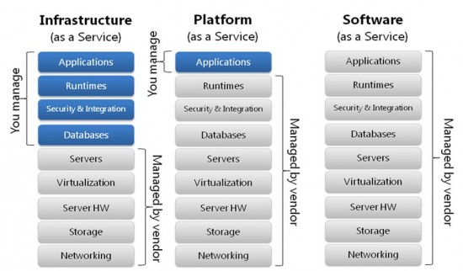

Comparison between IaaS, PaaS, SaaS (Find a way forward in the cloud vs. virtualization debate, 2020)

As u can see the main differences with these Architectures are the Accessibility.

The IaaS lets u handle more components than PaaS and SaaS is completely handled by the Service provider.

## Public cloud vs Private cloud vs Hybrid Cloud (cloud categorization by accessibility)

### Public cloud

* The most common cloud computing.
* The cloud servers (hardware) is owned by the service provider
* Easy and affordable compared to other types

### Private Cloud

* Exclusive to a single company
* This can be placed inside the company premises or outside
* Only accessed and controlled by the company employees

### Hybrid Cloud

* Combination of both Public and private clouds
* Some functionalities are handled by the public cloud while private cloud handles the company exclusive operations.

## Why Cloud Computing is better compared to other Technologies for this situation

Cloud vs Traditional Servers

* Do not have to manage the hardware.

For supermarket chain company you wound must use extra resources to maintain a traditional server.

* Cloud provides the same level of security and control as the traditional servers

When implementing an IT solution security is utmost important. When building a dedicated server handling, the security is handed to the company itself. but when using a cloud hosting platform most of the security is handled by the cloud provider which are more qualified and guaranteed to make your server secured.

* Cloud is more scalable compared to traditional servers. Especially when it comes to storage and it also cost efficient.in a cloud server storage can be added as needed.
* When it comes to backups cloud backups can be accessed from anywhere. but in traditional servers .and backups can be done regularly depending on your need.

Cloud vs Virtualized Deployment

* Virtualization and cloud technology share some functionalities.
* Virtual machine comfigure the current resources and limit them to each user .but the cloud is accessed as a whole (Public cloud /private cloud).
* Vertualization is mostle centerd on a one single machine . if one machine beaks down it have the potential to fail the whole system.

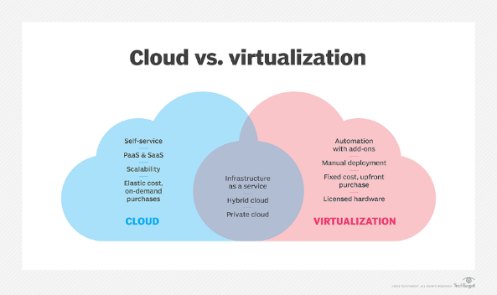

Similarities and Differences of Cloud and virtualization (Frampton and Frampton, 2020)

## My solution and Conclusion

In this scenario my solution is to use cloud Infrastructure as a service to implement the private cloud and use PaaS to implement the public cloud of the supermarket chain system.

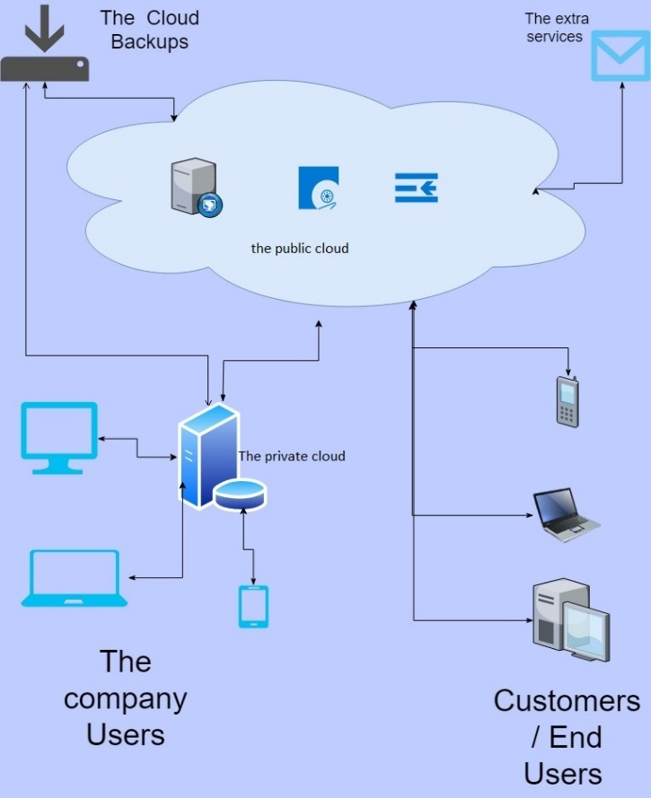As mentioned before when compared with the other technologies the cloud technologies show many advantages .it provides great flexibility and future improvements to the system.

Specially cloud as an Infrastructure makes sense in this scenario because of the control and the flexibility it provides. The Operating system, the Runtime and the application can be customized according to the company’s choice

In this scenario the I think its better to use cloud (IaaS) to use in the supermarket. It provides better suited environment to grow the business and give users the satisfactory experience.

## Bibliography

(cloud-computing noun - Definition, pictures, pronunciation, and usage notes | Oxford Advanced American Dictionary at OxfordLearnersDictionaries.com, 2020)

SearchServerVirtualization. 2020. *Find A Way Forward In The Cloud Vs. Virtualization Debate*. [online] Available at: <https://searchservervirtualization.techtarget.com/tip/Find-a-way-forward-in-the-cloud-vs-virtualization-debate> [Accessed 3 May 2020].

Frampton, K. and Frampton, V., 2020. *The Differences Between Iaas, Saas & Paas*. [online] SmartFile. Available at: <https://www.smartfile.com/blog/the-differences-between-iaas-saas-and-paas/> [Accessed 28 April 2020].